**Smart Door**

**Control Servo Motor with Ultrasonic Sensor**

**HC-SR04 Ultrasonic Sensor**

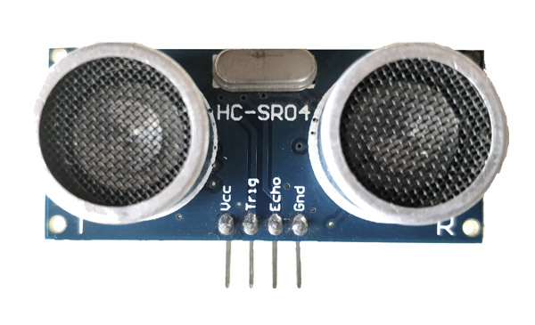

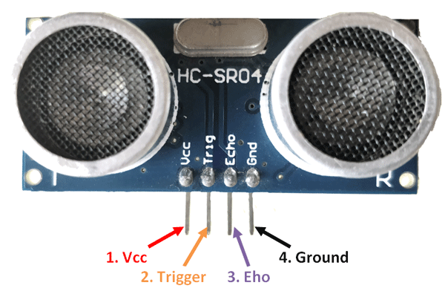

|  |  |  |
| --- | --- | --- |
| **Pin Number** | **Pin Name** | **Description** |
| **1** | **Vcc** | The Vcc pin powers the sensor, typically with +5V |
| **2** | **Trigger** | Trigger pin is an Input pin. This pin has to be kept high for 10us to initialize measurement by sending US wave. |
| **3** | **Echo** | Echo pin is an Output pin. This pin goes high for a period of time which will be equal to the time taken for the US wave to return back to the sensor. |
| **4** | **Ground** | This pin is connected to the Ground of the system. |

### ****HC-SR04 Sensor Features****

* Operating voltage: +5V
* Theoretical  Measuring Distance: 2cm to 450cm
* Practical Measuring Distance: 2cm to 80cm
* Accuracy: 3mm
* Measuring angle covered: <15°
* Operating Current: <15mA
* Operating Frequency: 40Hz

**This sensor is a very popular sensor used in many applications where measuring distance or sensing objects are required. The Ultrasonic transmitter transmits an ultrasonic wave, this wave travels in air and when it gets objected by any material it gets reflected back toward the sensor this reflected wave is observed by the Ultrasonic receiver module as shown in the picture below**

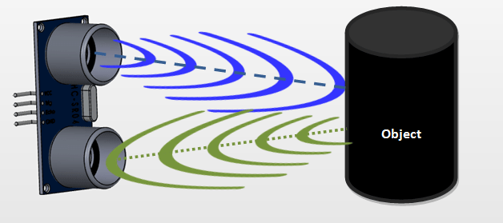

**To start the measurement, the trigger pin has to be made high for 10uS and then turned off. This action will trigger an ultrasonic wave at frequency of 40Hz from the transmitter and the receiver will wait for the wave to return. Once the wave is returned after it getting reflected by any object the Echo pin goes high for a particular amount of time which will be equal to the time taken for the wave to return back to the sensor.**

**The amount of time during which the Echo pin stays high is measured by the MCU/MPU as it gives the information about the time taken for the wave to return back to the Sensor. Using this information the distance is**

**Distance = Speed) 340 m/s) × Time / 2**

**Servo Motor**

**A servo motor is a rotary actuator or a motor that allows for a precise control in terms of the angular position, acceleration, and velocity .Basically it has certain capabilities that a regular motor does not have. Consequently it makes use of a regular motor and pairs it with a sensor for position feedback .**

**Servo motor works on the PWM ( Pulse Width Modulation ) principle, which means its angle of rotation is controlled by the duration of pulse applied to its control PIN. Basically servo motor is made up of DC motor which is controlled by a variable resistor (potentiometer) and some gears.**

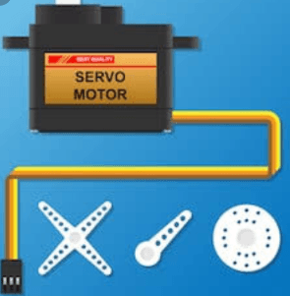

**Types of Servo motors in rotation :**

**- Standard Type : can rotate from 0 to 180 degree**

**- Modified Type : can rotate from 0 to 360 degree**

